**Kaif Ikhlaq**

**SU92 BSAIM S24 – 027**

**TASK : 6**

* 1:

The code performs a Breadth-First Search (BFS) on a graph, starting from a specified node. It explores each node level by level, marking visited nodes and appending unvisited neigh bors to the queue. The visited nodes are then printed.

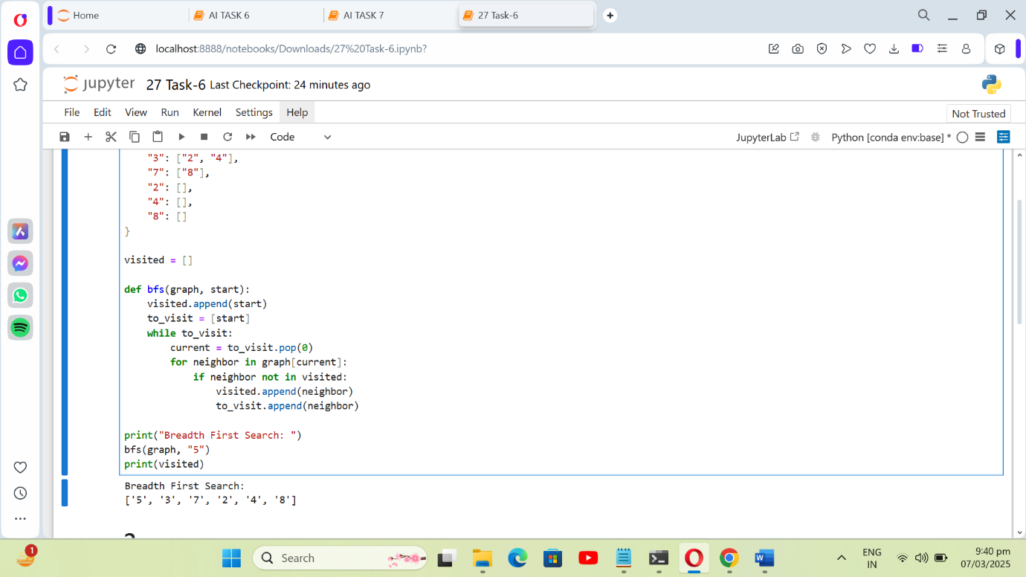

* 2:

The code implements a BFS to find the shortest path from a start node to a goal node in a graph. It tracks the path taken and returns the sequence of nodes from start to goal.

